Growing in Faith...Sharing Christ’s Love!  
TRINITY LUTHERAN CHURCH

# 2022 Annual Report

## 

## Welcome to Trinity’s Annual Report!

Included in this report are the Annual Meeting Agenda, the Annual Congregation Meeting Minutes, Pastoral Report, Congregational Council & Committee Reports, the Trinity Pines Annual Report & Official Acts. Click on one of the links to be taken to that portion of the report or scroll through as your please.

Annual Meeting Agenda

Sunday, June 5, 2022

1. Opening Devotion
2. Approval of the Minutes of the June 6, 2021 Annual Meeting
3. Reports of the Pastor, Congregational Council, Committees and others
4. Elections
   1. Congregational Council - 3 open positions for three-year terms
      1. Current Nominees: Darien Dierkes, Leah Fritsche, Kevin Mansfield
   2. Audit Committee - 1 position for a three-year term
      1. Current Nominees: TBD
   3. 2023 Synod Assembly Representatives (May 20, 2023, Kalahari Resort - Wisconsin Dells) - 2 people
      1. Current Nominees: TBD
5. Treasurer’s Report
6. Presentation, discussion and approval of the Budget
7. Unfinished Business
8. New Business
9. Project Renew Report
10. Closing Prayer

Annual Congregational Minutes

Sunday, June 6, 2021

1. The annual congregational meeting was called to order by Adam Smith, council president, on Sunday, June 6, 2021 at 9:23 am in the Gathering Space of Trinity Lutheran Church. There were approximately 30 people in attendance.
2. Devotions made by Pastor Mark Dressel.
3. Approval of minutes
   1. The minutes of the 2020 Annual Meeting were reviewed by those in attendance.
   2. Motion to approve the 2020 Annual Meeting minutes made by Karen Peters, second by Shawn Cannon. Motion approved.
4. Reports (it is ok if there is no report)
   1. Pastor: See Annual Report for 2021
   2. Church Council:
      1. Adam Smith (president): Adam started his report by thanking the council, pastor, and staff for digging in and keeping this place going through a very challenging year. A round of applause was had for the tech committee, especially through this past year with COVID, as their work made the transition to virtual worship fairly seamless and possible.
5. Elections
   1. Church council had three 3-year term positions & one 1-year position open. The current nominees brought forward to the congregation included KC Fresoln, Kim White, and Lou Burdick.
      1. Discussion:
         1. Darien Dierkes nominated himself for the final open position.
         2. Drew Schoeneck - Who would get each position?
            1. Pastor Mark said he was looking to just fill the positions at this point, and the council could decide what makes the most sense for the group. He also noted that the person filling the 1-year position could be elected to another term if they chose.
      2. Motion to approve the nominees made by Drew Schoeneck, second by Brad Rosecke. Motion approved.
   2. The Audit Committee had one 3-year term position & one 1-year position open. The current nominee brought forward to the congregation is Deanna Cannon.
      1. Discussion:
         1. Cheryl Mortensen was nominated for the final position by Mark Dressel.
      2. Motion to approve the nominees made by Drew Schoeneck, second by Brad Rosecke. Motion approved.
   3. Synod Assembly Representatives for 2022 - 2 spots open. (May 7-8, 2022 at Kalahari, WiDells)
      1. Discussion:
         1. Brad Rosecke nominated KC Frescoln & Terri McDonnell for the positions.
      2. Motion to approve the nominees made by Shawn Cannon, second by Steven Busch. Motion approved.
6. Treasurer Report/Presentation of the Budget: Jamie Stock
   1. As we started the budgeting process in the middle of the COVID-19 pandemic, we didn’t know what to expect. In the end, we were extremely blessed financially this year. The total income was over $290,000.00 and expenses came down about $10,000.00 from previous year, which means Trinity came in almost $30,000.00 under budget. Trinity ended the year $32,000.00 ahead and was able to add almost $56,000.00 to Trinity’s surplus due to the forgiveness of a Paycheck Protection Program loan. Other highlights include passing on over $20,000.00 to the greater church, retiring $2,000.00 in Trinity notes, paying off the Project Renew loan, and replacing the twin furnaces with additional funds from Project Renew.
      1. Questions:
         1. Karen Peters - How much do we still owe on the mortgage?
            1. Just over $75,000.00, we will have the building paid off in just over 2 years.
   2. The budget for the coming year was set similarly to what we have had in income from the past couple years. In addition to having more of an idea of where COVID-19 would take the church with the budget compared to the past year, Trinity has added giving from people who are supporting the church online. Therefore, there were only small changes to the operational budget. The most notable changes include increasing benevolence closer to 10% and reducing the repairs & maintenance line item for the church due to the fact that we budgeted more last year due to needing to replace the twin furnaces.
      1. Questions:
         1. Mike Branzolewski - Are there any new significant line items?
            1. No.
         2. Mae Laatsch - Have you looked at quotes on the copier? Do you have something in mind for the next purchase.
            1. This is not something we’re looking at currently as the copier is something we aren’t using as often anymore. It was also noted that it is beneficial to wait to look at information about purchasing tech equipment such as this when you actually need it because the technology changes so quickly.
         3. Drew Schoeneck - Regarding the reduced amount on the church repairs/maintenance line item, was the $8,000 due to the furnace replacement?
            1. Yes. We dropped this budgetary line item due to the twin furnaces being replaced with funds from Project Renew and not needing to keep that amount as high.
         4. Brad Rosecke - What is the rate on the mortgage and what are the thoughts on paying the mortgage off considering the large increase in Trinity’s surplus?
            1. Right at 3%. And due to the fact that we only owe just over $75,000.00, we are currently not paying much in interest. We will keep this suggestion in mind for the future.
         5. Motion to approve the 2021-2022 budget as presented made by Brad Rosecke, second by Karen Peters & Darien Dierkes. Motion approved.
7. No Unfinished Business
8. New Business
   1. Council’s Strategic Vision - Adding Pastoral Support: Adam Smith (president)
      1. Council has been working on a 5 year strategic vision. At this point if we want to grow as a congregation it seems like we will need more help with our staffing options. Council is looking at adding pastoral support with current options being a 2-year half time intern, a 1-year full time intern, or looking at a first call full-time pastor. Adam presented rough numbers and asked for a general opinion of the congregation.
   2. Discussion
      1. Mae Laatsch - What does Pastor Mark prefer?
         1. Pastor Mark - There really isn’t a good way to answer that. It really depends on the person and what they can bring to the organization.
         2. Sue White - One thing to consider about having an intern is that it becomes a ministry of the church. It could become a mission of this community and so that may need to be something the congregation decides is important to them.
      2. Mike Branzolewski - Do we have a list of ideas and jobs to make bringing in more help worth it?
         1. Pastor Mark - This really depends on the skills of the person. We do know that certain times like events and Sunday mornings are busy and the church would benefit with more connection being made on that pastoral level.
      3. Drew Schoeneck - Has the council looked at other churches for how adding staff would work? TRinity has had a director of music ministry, is this something we would look into?
         1. Adam Smith - Council sees the benefits of having someone in a pastoral role as it helps Pastor Mark.
         2. Pastor Mark - One thing that is generally accepted is that a 200 person average attendance at worship is the max of what one pastor can do. Trinity is currently around the 170-180 average. Pastor Mark noted that this is one of the reasons he thought council pursuing this was a good idea,
      4. Darien Dierkes - Which option was Vicar Sterling?
         1. Adam Smith - A two year, half time intern. It was noted that his position was also paid for with grants.
      5. Monica Hall - What are the availability of candidates?
         1. Sue White - There are quite a few interns available every year.
      6. Karen - What is the plan discussing further?
         1. Shawn Cannon - If there are more questions, please share with Pastor Mark or council.
9. Closing Prayer offered by Adam Smith.
10. Adjourn
    1. Motion to adjourn made by Karen Peters, second by Julia Wolfgram. Meeting adjourned.
11. Submitted by Makenzie Rosol, Office Administrator

Pastoral Report for the 2021-2022 Year

***“For as the rain and the snow come down from heaven  
    and do not return there until they have watered the earth,  
making it bring forth and sprout,  
    giving seed to the sower and bread to the eater,  
11so shall my word be that goes out from my mouth;  
    it shall not return to me empty,  
but it shall accomplish that which I purpose  
    and succeed in the thing for which I sent it.”*** (Isaiah 55:10-11 – NRSV)

Dear Friends,

Between the church parking lot and the parsonage backyard is a hedgerow that is presently bursting with new growth. There was a period of time when it had an unfortunate twelve foot gap in the middle of it.

This was around fifteen years ago. There was a tree that needed to be taken down in the backyard of the parsonage. The problem was getting the bucket truck close enough to take it down safely. The only way to get to the tree was through the hedgerow. The people facilitating the project considered the situation and said, no problem, bushes regrow after you cut them back. Plus, it was winter, so they were dormant. They cut several of the bushes off at ground level, enabling the workers to drive the truck through the gap, across the frozen ground. They took down the tree and hauled the wood away. The bushes were supposed to grow back in the spring.

It was as good of a plan as anyone could think of. And it worked out as well as it could. The part that I did not anticipate was that while the bushes in the hedgerow *started* growing back in the spring, it was *years* before it looked normal again. It took a long time for that gap to disappear.

I feel like we are in a similar situation as far as our world and congregation are concerned. As a group, we have navigated COVID as well as we could. But our losses have been real, from loss of health and life for some to loss of education and employment for others. And while we as a group are beginning the process of recovering, somehow I expected it to be faster. In my dreams, the pandemic and its ongoing effects would have disappeared with the arrival of spring in 2021. In reality, it has continued to linger, causing grief, disruption and even death.

And so how is the church doing in the world circumstances such as they are?

As always, with God, the church is well. Hardship, trials, and even death cannot overcome or discourage this community built on the “foundation of the apostles and prophets, with Christ Jesus himself as the cornerstone” (Ephesians 2:20) which includes a great “cloud of witnesses” (Hebrews 12:1) that surround us with inspiration and love.

That being said, just because the church, the body of Christ in heaven and on earth, is doing well does not mean that every local congregation is thriving right this moment. So how is Trinity doing? How is *your* church home?

This past year has seen ministry taking place in the midst of a world navigating a lingering pandemic.

We entered the summer of 2021 with high hopes that life would return to normal quickly. The National Youth Gathering had been delayed by a year (it would later be canceled altogether) and confirmation had been held outdoors out of an abundance of caution, but we believed that these would be the last events we would need to adjust.

We planned to hold Vacation Bible School largely indoors at the beginning of August, hoping that COVID would be a memory by then. The pandemic, however, did not evaporate and as we approached August the COVID numbers remained uncomfortably high. Our faithful leaders finally decided to move VBS outside as much as possible. It was a good decision and a fine event, with 69 students participating, which easily topped the 26 students that took part the year before, yet short of the 100-ish per year we had before the pandemic.

Also, over the summer, we went through some administrative transition. Our Office Administrator, Cate Urbas, who served faithfully for over eight years, moved to a new position with the Stoughton School District in mid-July. Deanna Canon stepped up to help the church through the transition and to prepare the way for Makenzie Rosol, who started on August 31. Makenzie’s diligent work and friendly demeanor have been a blessing in her first nine months on the job.

As we entered the fall, with COVID numbers lower than in the past and treatment options improving, people and organizations began to hold more in-person events and Trinity’s in-person events and involvement slowly increased from pandemic lows. Ministry leaders, with council approval, decided to hold Sunday School, Youth on Wednesday, and Senior High on Wednesday in-person, which greatly increased participation over last year’s labor-intensive virtual efforts.

In worship, as we progressed through the school year, the overall number of people signing in declined slightly over the previous year, but the number of in-person participants increased. We continue to be blessed with leadership from volunteer song leaders. Hand Bells, were a staple for musical variety through the school year, largely because you can play the bells while wearing a mask. As the year progressed, we had other special instrumental music, such as euphonium solo, brass quintet and violin/cello duet. Adult choir remained on hiatus. Advent featured a cantata by an expanded worship band. We had a virtual Sunday School program which was recorded on December 5 and 12, and shown in worship on December 19. Christmas Eve featured three worship services with many people in-person. As we progressed into Lent, Wednesday evening worship featured interviews with friends and members of Trinity who told about people that had inspired their faith. Maundy Thursday included an in-person living last supper. Easter Sunday had three worship services, Easter breakfast, and an Easter Egg hunt between the middle and late worship services. The school year finished with a flurry of events as children’s choir sang on Palm Sunday and the last day of Sunday School, we held confirmation for 13 students, we presented Senior Blankets to 8 students in person and more throughout the following week, and we celebrated first communion with 9 fifth graders. In general, virtual attendance remained significant, while in-person attendance continues to recover.

Throughout the year, Wine Women and Word and Sunday Adult Bible Study continued to meet. Faith Fellowship and Football got together for two games. The high school students planning to go to the National Youth Gathering (now scheduled for 2024) held fundraisers including brat sales and a sub sandwich sale. September and May both featured movie nights with the May showing raising money to help the people of Ukraine. In December, Trinity’s Christmas Tree Sale raised $6,200 and in April, YOW’s Food Scavenger hunt collected 1,039 pounds of non-perishable goods for the Lake Mills food pantry.

As we look toward next year, we are hoping to grow a little further out of the pandemic with Vacation Bible School using both indoor and outdoor space. Fellowship plans include a Mallards baseball game and an outing to the Fireside. We’re hoping to do some long range planning as we move into fall, and kick off the year of Sunday School, YOW, and SHOW with renewed energy and enthusiasm.

Thank you so much to everyone who has used their God-given gifts and abilities to help Trinity through this year of recovery. Special thank you to our musicians, to our audio-video and tech team, to those who worked with sign-in, to those who facilitated special events, and to those who worked with kids and young adults. Thank you to our administrative, financial, and musical staff and volunteers who adapted to help support us through a year of recovery. Thank you to our Executive Committee and Council who deliberated what was best for the group. Thank you so much to everyone who includes Trinity as part of the ministry that God has given you in this world and who generously supports the congregation in any and every way.

Through this year of slow regrowth that we have had, I take comfort that God’s ability and desire to bring life will not be deterred. As God said through the prophet Isaiah, “*For as the rain and the snow come down from heaven and do not return there until they have watered the earth, making it bring forth and sprout, giving seed to the sower and bread to the eater, 11so shall my word be that goes out from my mouth; it shall not return to me empty, but it shall accomplish that which I purpose and succeed in the thing for which I sent it.”* (Isaiah 55:10-11 – NRSV)

I look forward to seeing what God will do with our shared efforts in the year to come.

Blessings,

Pastor Mark

***I am confident of this, that the one who began a good work in you will continue to complete it until the day of Jesus Christ.***  (Philippians 1:6 - NRSV)

Submitted by Pastor Mark Dressel

Council & Committee Reports for the 2021-2022 Year

Greetings Church Family,

2021-2022 has been a strange year but also an encouraging one both within Trinity and its congregation and throughout the wider world. It was so exciting to start having larger groups in the sanctuary for worship, to start seeing members faces again and being able to stay and chat awhile, catching up on how things have changed and how they haven’t. It was encouraging to see families come back to services and Sunday School, to hear laughter and singing and conversations. There were richer and fuller Christmas and Easter services, whose absences were felt by many and now felt hopeful. This is a congregation that is strong, with people who refused to give up as a group during the pandemic and who held this family together. I am hoping that as the summer excitement of VBS builds and then we move back into fall, the pews will be packed, the activities will return in full swing and everything that binds a church family together will continue to fill up the members of this congregation with Jesus’s message of love, hope, and grace. With all God’s blessings…..

Submitted by Leah Fritsche, Council President

Hello all,

There were plenty of educational opportunities this past year. For adults, we had bible study between services on Sundays. For grades 9-12, we had Senior High on Wednesday (SHOW). For grades 6-8, we had Youth on Wednesday (YOW). Finally, we had Sunday School, with the biggest event being the Friendship Fair. This is always a fun event to get children interested and signed up for Sunday School for the year.

Last but definitely not least, we had Vacation Bible School (VBS). Last year we called every family that has been to VBS in the past, which we will do again this year. The families that didn’t belong to the church were very grateful for the reminder! Also, there is the parade, which is a fun event for all of us! We can walk and represent our church, while inviting children to VBS!

Sincerely,

Lou Burdick

Submitted by Lou Burdick, Education Committee Chair

Greetings everyone,

Evangelism by definition means, “The spreading of the Christian Gospel by public preaching or personal witness.”

Evangelism, simply put, is telling the good news, to simply share with another person good news. And it could mean any good news, but in the biblical sense, the word evangelism refers to the good news about Jesus.

Here at Trinity, our mission is “Growing in Faith Together” This year as the Evangelism chair, I’ve tried to spread the word to others in our community, the way our members spread the word of Christian gospel through the year.

We’ve started a program with Brewer and Packer schedules that are personalized with Trinity’s worship schedule to encourage and reach out to families in our community to increase membership numbers. We will be sending these schedules to 700 Lake Mills homes throughout the city and township.

Being a member of Trinity for 55+ years, I’m always so proud of the way our members work together to benefit those in need, not only in or community, but through out the world. We are truly spreading Christian Gospel through words, acts, and deeds.

#Trinitystrong

Sincerely,

Heidi Kabat Evangelism Chair

Submitted by Heidi Kabat, Evangelism Committee Chair

**2021-2022 Annual Treasurer Report**

We entered the 2021-2022 budget year as the worldwide pandemic continued to disrupt our lives. The 2021–2022 annual budget passed during the June 2021 annual meeting with a projected income of a little over $290,00 and budgeted expenses of $287,470. With the pandemic continuing we were hopeful that the generous giving of the prior year would continue as the world slowly opened back up to normal activities to cover the projected expenses.

The financial results for the 2021 – 2022 fiscal year included $288,739 of income which more than covered the $269,679 in expenses. Expenses did rebound back to normal levels as the church resumed most of the normal activities. Giving continued to be strong throughout the year which was a wonderful blessing after a couple of difficult pandemic years. The combination of controlled expenses paired with continued higher giving allowed us to add $19,059 to our surplus. We commend and thank the staff for their continued efforts to control the level of spending and thank the congregation for their continued generosity.

The month by month income and expenses can be found in Exhibit A and the month by month expense compared to budgeted expenses can be found in Exhibit B.

Financial highlights from the 2021–2022 fiscal year include:

* Funded church operations and staff salaries and benefits ~$17,800 below budget
* Passed on $24,665 to the greater church from our operating budget and individual contributions
* Paid $2,365 in block income to the mortgage principle
* Added $1,000 to the funds to savings for a sabbatical for Pastor Mark
* Added $500 to the funds to savings for new computer equipment
* Added $1200 to the funds to savings for a new copier
* Added $8,875 to savings for the sanctuary lighting

We thank everyone for their generosity and continued commitment to the ministries of Trinity. We pray that we continue to grow as a congregation both physically and spiritually and continued to be blessed with great volunteers and staff. As you evaluate your giving in the upcoming year, consider your blessings and all the great things that are going on here at Trinity and beyond our walls.

Respectfully Submitted,

Jamie Stock

Submitted by Jamie Stock, Treasurer

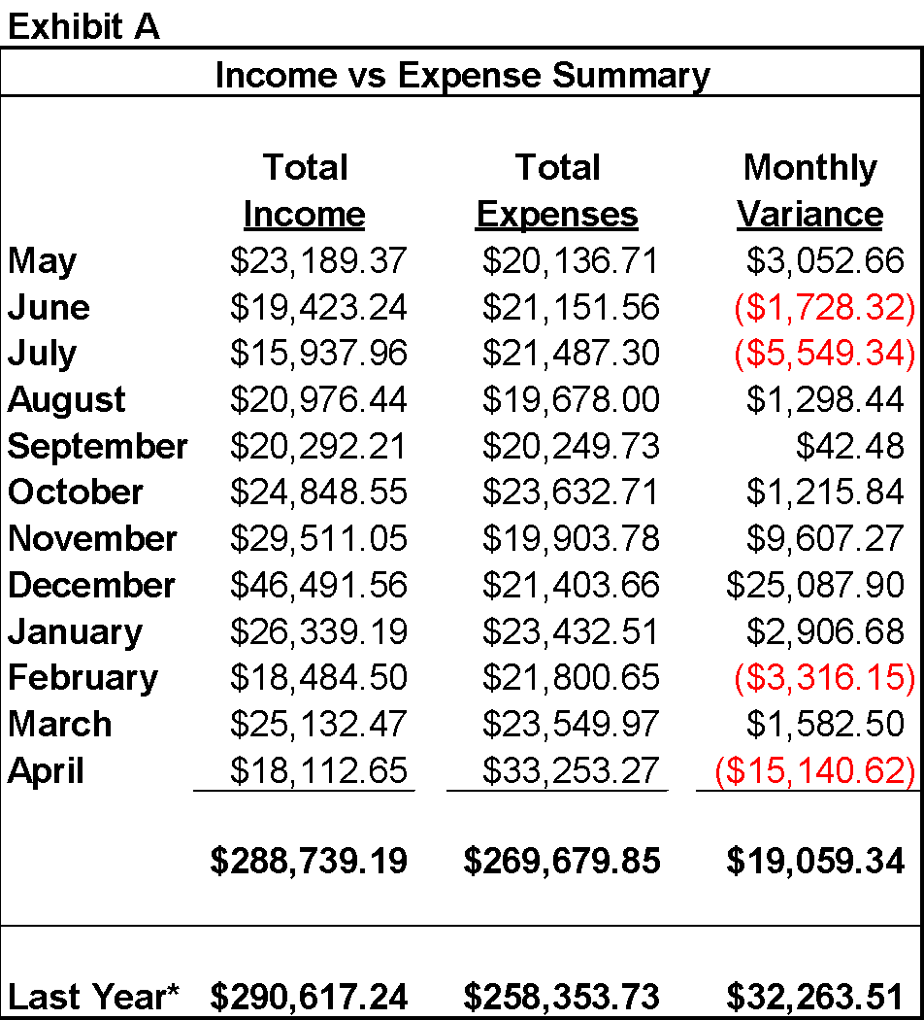

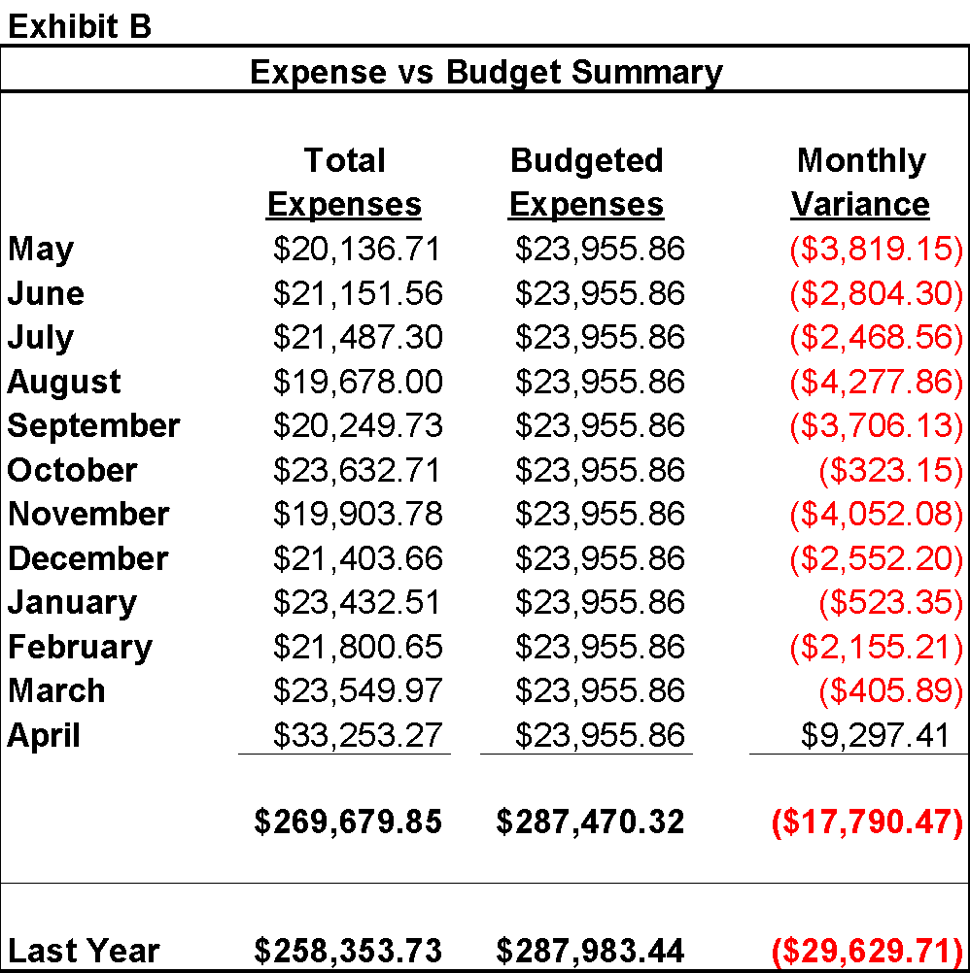

Trinity Pines Annual Report for 2021

Submitted by Bob Dimperio, President, Board of Directors &

Ann Lee, Managing Director

The inspiration for Trinity Pines started in the mid-1980s when the members of Trinity Lutheran Church sought to extend their mission by developing a senior living community. These members worked with community leaders and Wisconsin Housing & Economic Development Authority to design and build a community that would allow Lake Mills area residents to retire comfortably in the city where they had been living. In our residents today, we see a nice blend of people who grew up here and those who are here to be close to children and grandchildren and even great-grandchildren.

“The Pines” is a non-profit corporation dedicated to providing for resident’s physical, social, psychological, and spiritual needs and to promote their health, security, happiness, and usefulness in longer living. The community is open to all, aged 60 and up, regardless of church affiliation.

A nine-member volunteer Board of Directors, with representatives from Trinity Lutheran Church, the community, and a resident representative provides general oversight with operations under the direction of the Managing Director, Ann Lee. The Board and Ann, as well as all employees, are committed to our mission.

Trinity Pines features a combination of 39 apartments with 1 and 2 bedroom floor plans, a beautiful community gathering room, coffee nook, sun room & patio, hair salon, library, activity and craft space, screened-in patio, laundry facilities on each floor, pool table, exercise room, and underground heated parking.

The Covid-19 pandemic has continued, requiring community changes in the interest of health and safety of residents and staff. We recognize and thank our residents who have made adjustments in their lifestyle to help keep themselves and their neighbors healthy.

As we complete the 33rd year of operation, The Pines continues to maintain a sound financial position. Based on the most recent financial statement, the non-profit corporation’s assets totaled $4,704,243 and liabilities totaled $2,299,639, resulting in a net worth of $2,404,604. In addition, a positive cash flow was experienced for the year. Occupancy remained constant for most of the year with some vacancies at year end.

The Board understands the need to maintain and upgrade the facility. A resident-accessible Coffee Nook was constructed in the gathering room with new cabinets, countertop and backsplash, sink & faucet. Continuing with a multi-year project, a number of apartment patio doors were replaced with the final replacements delayed until 2022 due to material shortages. The replacement of all apartment draperies has been approved with installation planned for 2022.

We have learned the digital world is important for our marketing efforts. With the impact of the Google search engine, we encourage those familiar with The Pines to write a short review on Google. These reviews considerably help potential residents and their families while researching senior living facilities. The Trinity Pines Facebook page continues to be updated with frequent posts to engage our over 400 followers. Please take a moment to “Like” and “Follow” us for a glimpse into the life of residents. The Lake Mills Leader publishes a monthly column, “Tracking Trinity Pines” written by long time employee, Sharon Kassube.

We recognize the longevity of our dedicated personnel with having Ann Lee with us coming up on 10 years and Sharon Kassube will celebrate 20 years. Loretta Grossman has helped in the office for 18 years and Carl Reinemann will mark his 2 year anniversary as Maintenance Technician.

Our current residents range in age from 68 to 98. We have 11 Nonagenarian members in our Club 90, which was started in 2014. This is a wonderful testament to the benefits of communal living and socializing.

We recognize and thank all of the residents who volunteer their time and energy to help make living at Trinity Pines so enjoyable. Examples include the individuals who do things like check that exterior doors are locked at night, seasonally decorate common areas, deliver daily newspapers, show the weekly movie, help neighbors with rides, and call Bingo. The participation and willingness to help is greatly appreciated and is a part of what makes The Pines so special.

Word of mouth is our absolute best form of advertising, so I encourage members of the Trinity Lutheran congregation to become more acquainted with this outstanding community asset and spread the word. Tours of the building are available at your convenience by contacting Ann Lee or Loretta Grossman. See for yourself how what we provide helps residents thrive!

Bob Dimperio, President, Board of Directors & Ann Lee, Managing Director

Presented December 15, 2021

Official Acts for the 2021 Year

Submitted by Makenzie Rosol, Office Administrator

## BAPTISMS (9)

**February 28, 2021**

Aria Camille Schiller (born: 05/28/2020)

Sponsors: Jim Jensen & Lisa Hengst

Parents: Tyler & Jennifer Schiller

**April 25, 2021**

Everest Richard Jaeckel (born: 03/01/2021)

Sponsors: Miranda Gosda & Cody Heine

Parents: Abbey & McKinly Jaeckel

**May 8, 2021**

Isabel Violet Silberzahn (born: 07/03/2020)

Sponsors: Mark & Amanda Vig & Kate Tang

Parents: Bill & Gillian Silberzahn

**May 23, 2021**

Jade Mansfield (born: 04/26/2018)

Sponsors: Brendan & Justina Dolan

Parents: Kevin & Amanda Mansfield

**May 23, 2021**

Reagan Mansfield (born: 11/03/2020)

Sponsors: Brendan & Justina Dolan

Parents: Kevin & Amanda Mansfield

**July 25, 2021**

Walter Charles Topel (born: 04/03/2020)

Sponsors: Austin Gottman & Katie Gottman

Parents: Mackenzie & Keegan Topel

**November 13, 2021**

Ethan William Steindorf (born: 04/26/2021)

Sponsors: Brittany Hill & Rachel & Kevin Kvasnica

Parents: Matt & Nicole Steindorf

**December 5, 2021**

Maci Joelle Hergert (born: 09/20/2021)

Sponsors: Daniel Hergert & Kristen Irwin

Parents: Joshua & Maegan Hergert

**December 19, 2021**

Logan Philip Kensgaard (born: 06/20/2019)

Sponsors: Alex Kensgaard & Diane Basting

Parents: Erik & Amanda Kensgaard

## WEDDINGS (2)

**June 6, 2021**

Names: Steve Ursin & Gina Bromberg

Commons Park - Lake Mills, WI

**July 3, 2021**

Names: Fancisco Alcala Reyes & Amanda Hoppe

Bennett Barn - Watertown, WI

## 

## FUNERALS (10)

**Kenneth C. Vallier Sr.**

Born: May 11, 1942

Died: Wednesday, February 3, 2021

Funeral: February 16, 2021

Burial at Lake View Memorial Park - Oshkosh, WI

**Lou Ann Ward**

Born: March 31, 1934

Died: Saturday, February 13, 2021

Funeral: February 18, 2021

Burial at Washington Cemetery - Portland, WI

**Richard Severin**

Born: June 10, 1941

Died: Wednesday, March 24, 2021

Funeral: April 1, 2021 at Claussen’s Funeral Home

**William “Bill” Spencer Nelson**

Born: October 29, 1963

Died: Monday, April 5, 2021

Funeral: April 10, 2021

**Sally Zitelman**

Born: August 12, 1943

Died: Tuesday, June 15, 2021

Funeral: June 23, 2021

Burial at Rock Lake Cemetery on June 24, 2021

**Alex Wuestenberg**

Born: November 5, 1988

Died: August 25, 2021

Funeral: September 4, 2021

Rev. Brian Bill (Uncle of Alex) presided

**Daniel William Morrow**

Born: January 15, 1953

Died: September 2, 2021

Funeral: September 10, 2021

**Thomas “TK” E. Kempfer**

Born: August 24, 1946

Died: October 31, 2021

Funeral: November 5, 2021

**Eileen C. (Weigel) Behling**

Born: August 31, 1921

Died: November 10, 2021

Funeral: November 19, 2021

**Alydia Cora (Benson) Anderson**

Born: August 2, 1930

Died: December 5, 2021

Funeral: December 10, 2021

Burial: Rock Lake Cemetery

## CONFIRMED (9)

#### 

#### May 2, 2021

**Alex Breaker**

Parents: Chad & Jeni Breaker

**Michael Fuglestad**

Parent: Darin Fuglestad

**Mason Fuglestad**

Parent: Darin Fuglestad

**Cora Nelson**

Parents: Josh Nelson, Laura Kalvestran, & Teri Galbraith

**Tyler Patrick**

Parents: Chad & Dawn Patrick

**Payton Quest**

Parent: Misty Quest

**Max Ruedebusch**

Parents: Michael Ruedebusch & Kirsten Menzies

**Kristina Thomas**

Parents: Scott & Lisa Thomas

**Zachary Twesme**

Parents: Scott & Steph Twesme

## 

## NEW MEMBERS (32)

#### New members received on May 20, 2021

Josh Nelson & Laura Kalvestran (Cora & Lila)

#### 

#### New members received on May 23, 2021

Daniel Bennett (Madeline, Connor, Landon, & Kailey)

Chad & Rhonnie Garcia

Kevin Kaufman & Sharon O’Reilly (Rojina Kaufman)

Kevin & Amanda Mansfield (Jade & Reagan)

Nathan Romano & Kelly Tynan (Giovanni Romano, Laina & Thea Tynan)

Gail Wolf

#### New members received on June 11, 2021

Mike & Danelle Mueller

New members received on November 21, 2021

Wayne Johnson

New members received on December 15, 2021

Doug & Paula Siegert ( Mady, Lauren, & Payton)