Growing in Faith...Sharing Christ’s Love!  
TRINITY LUTHERAN CHURCH

# 2023 Annual Report

## 

## Welcome to Trinity’s Annual Report!

Included in this report are the Annual Meeting Agenda, the Annual Congregation Meeting Minutes, Pastoral Report, Congregational Council & Committee Reports, the Trinity Pines Annual Report & Official Acts. Click on one of the links to be taken to that portion of the report or scroll through as your please.

Annual Meeting Agenda

Sunday, June 11, 2023

1. Opening Devotion
2. Approval of the Minutes of the June 5, 2022 Annual Meeting
3. Reports of the Pastor, Congregational Council, Committees and others
4. Elections
   1. Congregational Council - 3 open positions for three-year terms
      1. Current Nominees: Chely Morrow, Eugene Syvrud, Bob Dimperio
   2. Audit Committee - 1 position for a three-year term
      1. Current Nominees: TBD
   3. 2024 Synod Assembly Representatives (May 17-18, 2024) - 2 people
      1. Current Nominees: TBD
5. Treasurer’s Report
6. Presentation, discussion and approval of the Budget
7. Unfinished Business
8. New Business
9. Closing Prayer

Annual Congregational Minutes

Sunday, June 5, 2022

1. The annual congregational meeting was called to order by Leah Fritsche, council president, on Sunday, June 5, 2022 at 9:20 am in Trinity Lutheran Church’s Gathering Space. There were approximately 34 members in attendance.
2. Opening devotion and prayer was led by Pastor Mark Dressel.
3. Approval of 2021’s annual congregational meeting minutes
   1. 2021’s meeting minutes were reviewed by those in attendance.
   2. Motion to approve the minutes made by Drew Schoeneck and seconded by Shawn Cannon. Motion was approved.
4. Pastor, Congregational Council, Committees, and others Reports
   1. Pastor thanked the congregation for their help with ministry throughout the year. His report along with the Congregational Council report, Committees’ reports, and other reports are included in the 2022 Annual Report packet.
5. Elections
   1. Elections
      1. **Church Council** – 3 open positions (all 3-year terms). The 3 current nominees brought forward are: Leah Fritsche, Kevin Mansfield, and Jason Hafenstein.
         1. Motion to approve the nominees made by Dan Zastrow with a second by Steven Busch. Motion was approved.
      2. **Audit Committee** – Pastor and the congregation thanks Cheryl Mortensen for her work on the audit committee this last year. There is 1 open position for a 3-year term. Mae Laatsch nominated herself.
         1. Motion to approve the nomination made by Darien Dierkes with a second by Shawn Cannon. Motion was approved.
      3. **2023 Synod Assembly Representatives** – The Synod Assembly will be taking place on May 20, 2023 at the Kalahari Resort in Wisconsin Dells. We are able to send two people and a youth representative. Shawn and Deanna Cannon nominated themselves and will have Chloe be the youth representative.
         1. Motion to approve the nomination made by Mike Branzolewski with a second by Heidi Kabat. Motion was approved.
6. Treasurer’s Report
   1. We entered the 2021-2022 budget year as the pandemic continued to disrupt our lives. At the 2021 annual meeting, we passed a budget of income projected at a little over $290,000 and expenses at $287,740. We have been blessed by the congregation this fiscal year with giving slightly under $289,000 and expenses were slightly under $270,000 which allowed us to add to the surplus by $19,000.
   2. Pastor led a discussion on visioning for the future. We are blessed to be in the position we are in. Our mortgage will be paid off in a little over a year. We do have a major expense on the horizon we have to think about with our parking lot. However we are in a position where we can begin to think about the vision for our future. Good decisions can be made when we have time to think and plan, we can dream about our future a little and be able to plan for the future. There will be information coming as Pastor and KC Frescoln (long range planning committee chair) discuss beginning steps for our visioning.
7. Presentation, discussion, and approval of the 2022/2023 Budget
   1. Budget for the coming year was set looking at what giving and expenses have been for the prior year. Income for the 2022/2023 fiscal year is budgeted to be $288,660 and expenses are budgeted to be $281,604 giving us a surplus of $7,000. The expenses include salary increases of 3% for both Pastor and Makenzie and a 2% increase for all other office staff and piano players.
   2. Questions on the budget?
      1. Doug Huseth – Does Trinity own Trinity Pines?
         1. Pastor Mark – We helped start Trinity Pines but we do not have ownership of Trinity Pines.
   3. Motion to approve the 2022/2023 budget as presented was made by Mae Laatsch and seconded by Lou Burdick. Motion approved.
8. Unfinished Business
   1. Darien Dierkes – What is the status of looking for an intern pastor?
      1. Pastor Mark – there was one candidate we looked at but wasn’t going to be the right fit. Additional pastoral staff will be part of the visioning work we’ll be doing as we plan for the future of Trinity. If that’s the direction we go, we’ll look at how we support it, what does it look like, etc.
9. New Business
   1. No new business was brought forward.
10. Project Renew Report
    1. This was an accidental item on the agenda. There is no project renew report.
11. Closing Prayer offered by Pastor Mark.
12. Motion to adjourn made by Drew Schoeneck and seconded by Pastor Mark. Meeting adjourned at 9:48 am.
13. Submitted by Chely Morrow, Church Council Secretary

Pastoral Report for the 2022-2023 Year

***“Before the mountains were brought forth, or ever you had formed the earth and the world, from everlasting to everlasting you are God.”*** *Psalm 90:2 – NRSV*

***“Jesus Christ is the same yesterday and today and forever.”*** *Hebrews 13:8 - NRSV*

**“Amazed and astonished, they asked, ‘Are not all these who are speaking Galileans? 8And how is it that we hear, each of us, in our own native language? 9Parthians, Medes, Elamites, and residents of Mesopotamia, Judea and Cappadocia, Pontus and Asia, 10Phrygia and Pamphylia, Egypt and the parts of Libya belonging to Cyrene, and visitors from Rome, both Jews and proselytes, 11Cretans and Arabs—in our own languages we hear them speaking about God’s deeds of power.’”** *Acts 2:7-11 – NRSV*

Dear Friends,

In a fast-changing world, we long for something familiar, life-giving, and dependable. The Bible tells us that God fulfills this need in a way that nothing else can. God

* created us in God’s image (Genesis 1:27, Jeremiah 1:5),
* provides for us out of God’s love (Psalm 145:16, Matthew 6:31-33),
* redeems us from the power of sin (John 3:16, Romans 5:9-10),
* and guides us in ways that are healthy (Matthew 7:12, Galatians 6:2, Jeremiah 29:11, John 15:25-26).

Every human being is born with a God-sized hole in our hearts that can only be filled by a relationship with God’s self. It is the mission of the church to help people make a positive, life-changing connection with God through Jesus Christ (Matthew 28:19-20, Acts 1:8).

And at first glance it would seem that, because God does not change, the church would always be the same. But this is not true, because people change. The modern church was born telling the mighty acts of God in new languages (Acts 2:8-11) and still the church is adapting to share the faith of the parents in the language of the children (1 Corinthians 9:19-23).

What does this look like today?

Today the church (which includes world-wide church bodies, local congregations, small groups, and individual believers) uses traditional tools like worship, education, prayer, music, service, fellowship and more to help people recognize God’s work in our lives and grow in maturity of faith. These traditional practices, however, are being used in new ways as the world emerges from the effects of the pandemic and as technology makes it possible. More and more, we are seeing Zoom Bible studies, live-streamed worship, events facilitated by online registration and supported by online ordered supplies, and classes and music that use electronically previewed and downloaded materials.

So what has this looked like at Trinity this past year?

That is a good question. Last summer (June-Aug. 2022) was slow in terms of attendance and participation. Worship sign-ins were lower than 2021. Vacation Bible School participation was enthusiastic and valuable, but numerically lower than the previous year as well. The prevailing opinion among people that I talked to was that families were finally taking vacations that they had put off for the previous two years, and they simply were not in town.

The fall brought improved worship participation (slightly ahead of 2021, helped by a big turnout on All Saint’s Day to celebrate 50 years of service from Linda Disch), along with renewed participation in Youth on Wednesday and adult Bible Study. Adult choir and children’s choir both resumed singing. High School students hosted a trail of Trick or Treat for elementary students. We installed new LED track-lights in the sanctuary. And the tree sale was able to raise $5,100 for the food pantry. Oddly, Sunday School did not have as many children in attendance as I would have expected, in spite of a strong group of leaders and a renewed Christmas program, and Christmas Eve worship was not as highly attended as it has been in the past…although that might just be that people did not sign in, so we could not tell they were there.

Spring brought a Super Bowl Sub Sandwich sale, the return of the YOW lock-in, and return of in-person first communion class with seven students in attendance. Lenten worship services enjoyed higher participation than they have had in the last 15 years, helped by soup suppers, as we averaged over 75 per Wednesday to appreciate “Great Songs of Faith.” Easter morning had a strong showing as 398 people signed in over three worship services. Easter breakfast and an outdoor Easter Egg hunt helped bring people to church. The spring finished strong with confirmation, senior blankets, Sunday School teacher appreciation and a baptism. On top of all that, Trinity finished paying off the mortgage on the Sanctuary at the end of April! Thank you so much to everyone who helped!

As we proceed into the new year, we continue to do all that is in our power to help people connect with God in the lives that they are living. My sense is that people’s desire to have a relationship with their creator and their fellow human being is as strong as it ever was, but the way we go about meeting and organizing ourselves is different. Today, Trinity is streaming to YouTube and Facebook, organizing with Signup Genius, registering for events through Google forms, ordering supplies through e-commerce, projecting information with PowerPoint and Google Slides, and meeting over Zoom. It’s like we are talking a new language, but the church has always done that. God is still the same and God’s love is eternal. Our job is to share the faith of the parents in the language of the children so that this generation can stay strong in faith and the next generation can come to know God. Thank you so much for making Trinity part of your service to God in this world!

Yours in Christ,

Pastor Mark

Submitted by Pastor Mark Dressel

Council & Committee Reports for the 2022-2023 Year

Dear Friends:

This last year was a unique year. Sunday School tried a new teaching process for K-5 students. Teachers did an every other week process which worked out very well! It was a great plus for the teaching staff as well as for the students.

Submitted by Lou Burdick, Education Committee Chair

**2022-2023 Annual Treasurer Report**

We entered the 2022-2023 budget year as the world was stating to revert to some form of normalcy after the COVID pandemic. The 2022–2023 annual budget passed during the June 2022 annual meeting with a projected income of $288,660 and budgeted expenses of $281,604. It was the first year in some time that we were able to present a budget with a positive position. With the pandemic winding down, we were hopeful that giving would remain strong as activities resumed but we also knew expenses would also go up with the increase in activity and hopeful our budget would be sufficient.

The financial results for the 2022 – 2023 fiscal year included $289,891 of income which more than covered the $274,598 in expenses which was almost a $5,000 increase over the previous year. The increase in expense was expected given the higher inflation paired with the full spectrum of normal church activities. Giving continued to be strong throughout the year which was a wonderful blessing. The combination of controlled expenses paired with continued higher giving allowed us to add $15,294 to our surplus. The most exciting news in 22-23 fiscal year was that we were able to pay off the balance of our mortgage and retired our last Trinity Note leaving the church debt free by the fiscal year close! We commend and thank the staff for their continued efforts to control the level of spending and thank the congregation for their continued generosity.

The month by month income and expenses can be found in Exhibit A and the month by month expense compared to budgeted expenses can be found in Exhibit B.

Financial highlights from the 2022–2023 fiscal year include:

* Retired mortgage
* Retired the remaining Trinity Note
* Funded church operations and staff salaries and benefits ~$7,000 below budget
* Passed on $26,414 to the greater church from our operating budget and individual contributions
* Paid $875 in block income to the mortgage principle
* Added $500 to the funds to savings for a sabbatical for Pastor Mark
* Added $1500 to the funds to savings for new computer equipment
* Added $1200 to the funds to savings for a new copier
* Added $1500 to savings for outdoor lighting

We thank everyone for their generosity and continued commitment to the ministries of Trinity. We pray that we continue to grow as a congregation both physically and spiritually and continued to be blessed with great volunteers and staff. As you evaluate your giving in the upcoming year, consider your blessings and all the great things that are going on here at Trinity and beyond our walls.

Respectfully Submitted,

Jamie Stock

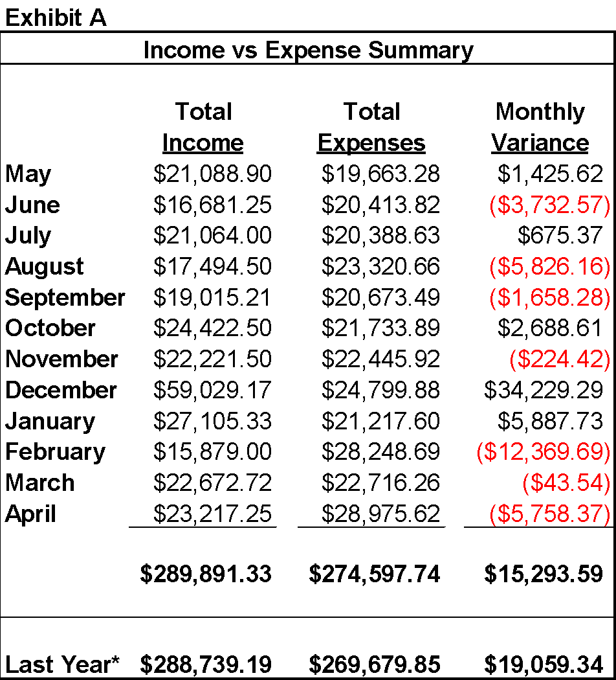

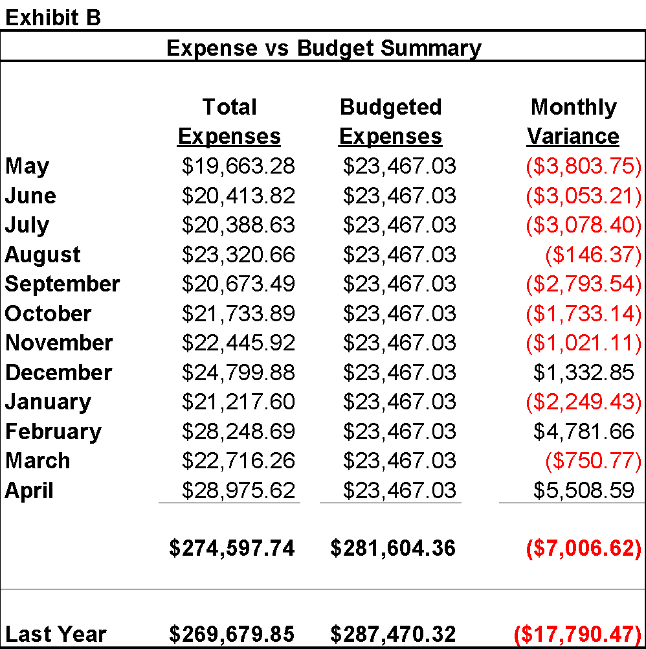

Submitted by Jamie Stock, Treasurer

Trinity Pines Annual Report for 2022

Submitted by Bob Dimperio, President, Board of Directors

Trinity Pines was established in 1988 when members of Trinity Lutheran Church extended their mission by developing a senior living facility for Lake Mills area residents. The Pines is operated as a non-profit corporation to provide our residents a healthy and safe environment, balancing independent living with a supportive community. The facility is open to all, aged 60 years and older, regardless of church affiliation.

A nine-member volunteer Board of Directors with representatives from Trinity Lutheran Church, the Lake Mills community, and Pines’ residents provides general oversight. Our new Director of Facilities, Carl Reinemann, who began in March directs operations. Two part-time employees provide assistance. Trinity Pines features 39 apartments with 1 and 2 bedrooms, community room, sun room, hair salon, library, activity and craft space, laundry rooms, and heated underground parking.

The Pines continues to maintain a sound financial position. Key financial data as of 12/31/22 as follows:

ASSETS

Total Checking and Saving $ 602,329

Other Current Assets $ 8,052

Fixed Assets $4,335,793

TOTAL $4,946,174

LIABILITIES

Current Accounts Payable $ 6,592

Deferred Entry Fees $1,576,772

Mortgage and Note Payable $ 735,156

TOTAL $2,318,520

NET WORTH $2,627,654

In addition, a positive cash flow was experienced for 2022. The facility is insured at full replacement cost,$9,500,000. The Pines maintained occupancy at a high level, ending the year at 100%.

The Board continues an emphasis on maintaining and upgrading the Pines. The final phase of the patio door replacement project and the replacement of all apartment draperies were completed this year. In addition, the parking lot lighting has been put back into operation.

Bob Dimperio, President, Board of Directors

Presented on January 23, 2023

Official Acts for the 2022 Year

Submitted by Makenzie Rosol, Office Administrator

## BAPTISMS (11)

**March 5, 2022**

Elliana May Kitsembel (born: 08/12/2021)

Sponsors: Rich Adams & Julia Quintana Cruz

Parents: Brett Kitsembel & Kasi Samson

**March 27, 2022**

Ryker Paul Adams (born: 02/14/2022)

Sponsors: Grace Jensen & Amanda & Dion Hupke

Parents: Andrew & Marissa Adams

**April 10, 2022**

Olivia Jun Russell (born: 12/14/2019)

Sponsors: Blaise Knueppel & Sarah Russell

Parents: Nathan & Yuu Russell

**May 7, 2022**

Cora Jo Schmidt (born: 04/30/2022)

Sponsors: Kassidy Wright & Logan Peot

Parents: Zach & Caylee Schmidt

**July 10, 2022**

Chloe Kay Gosdeck (born: 05/04/2022)

Sponsors: Scott Weideman & Kayla Gosdeck

Parents: Ryan & Karina Gosdeck

**July 10, 2022**

Bowen Neil Gosdeck (born: 05/04/2022)

Sponsors: Mitch & Mindy Bartczak

Parents: Ryan & Karina Gosdeck

**July 17, 2022**

Madison Rose Weber (born: 09/17/2021)

Sponsors: Mike Weber & Kayla Wiggand

Parents: Andy & Magen Weber

**July 23, 2022**

Valentineo Angel-Wolfgang Alwin-Brinckman (born: 04/08/2022)

Sponsors: Rod & Elizabeth Null

Parents: Mestizo Fredrick-Alwin & Amberlee Brinckman-Schroth

**October 23, 2022**

Collins Ashe Riedl (born: 06/27/2022)

Sponsors: Jon & Ashley Bartz

Parents: James & Hannah Riedl

**October 23, 2022**

Graceyn Nicole Riedl (born: 06/27/2022)

Sponsors: Jeff & Amanda Wozniak

Parents: James & Hannah Riedl

**October 23, 2022**

Hailey Jean Kuhl (born: 10/22/2019)

Sponsors: Jamie & Ashley Kuhl

Parents: Aaron & Connie Kuhl

## WEDDINGS (0)

**No Weddings**

## 

## FUNERALS (9)

**Karolyn Johnson**

Born: October 5, 1946

Died: December 27, 2021

Funeral: January 5, 2022

Burial at Roselawn Memorial Park, Madison, WI

**Joyce Mortensen**

Born: November 20, 1938

Died: March 28, 2022

Funeral: April 5, 2022

Burial at St. Peter’s Lutheran Cemetery, Reedsburg, WI

**Charlene Powers**

Born: January 26, 1955

Died: May 3, 2022

Funeral: May 10, 2022

Burial at Rock Lake Cemetery, Lake Mills, WI

**Aubrey Johnson**

Born: August 5, 1984

Died: May 7, 2022

Funeral: May 21, 2022

**Erdman “Chip” Gerstner**

Born: January 10, 1941

Died: June 28, 2022

Memorial Service: July 7, 2022

Pastor Mark did a prayer before the memorial service

**Sandy Zimmerman**

Born: July 31, 1941

Died: July 16, 2022

Memorial Service: July 22, 2022

Burial at Rock Lake Cemetery, Lake Mills, WI

**Eileen C. (Weigel) Behling**

Born: August 31, 1921

Died: November 10, 2021

Funeral: November 19, 2021

Burial at Rock Lake Cemetery, Lake Mills, WI on August 31, 2022

**Tom & Dian Reynolds & Becki Carr**

Memorial Service: September 17, 2022

**Joyce Key**

Born: December 6, 1931

Died: December 10, 2022

Funeral: December 15, 2022

Burial at Rock Lake Cemetery, Lake Mills, WI

## CONFIRMED (13)

#### 

#### May 1 , 2022

**Brady Benish**

Parents: Ryan & Jackie Benish

**Clara Branzolewski**

Parent: Mike & Linda Branzolewski

**Owen Burling**

Parent: Nick & Rachel Burling

**Chloe Cannon**

Parents: Shawn & Deanna Cannon

**Natali Cruz-Pfaff**

Parents: Jennifer Cruz

**Vance Dierkes**

Parent: Darien & Becky Dierkes

**Gabi Dressel**

Parents: Mark Dressel & Sue White

**August Fritsche**

Parents: Dave & Leah Fritsche

**Noah Hudson**

Parents: Chris & Amy Hudson

**Olivia Kiefer**

Parents: Joe & Becky Kiefer

**Kaden Smolinski**

Parents: Jim Smolinski & Brooke Phillipson

**Jaxon Stock**

Parents: Lance & Jamie Stock

**Violet Thompson**

Parents: Mike & Stephanie Thompson

## 

## NEW MEMBERS (1)

#### New member received on June 12, 2022

Carissa Minkebige

#### 